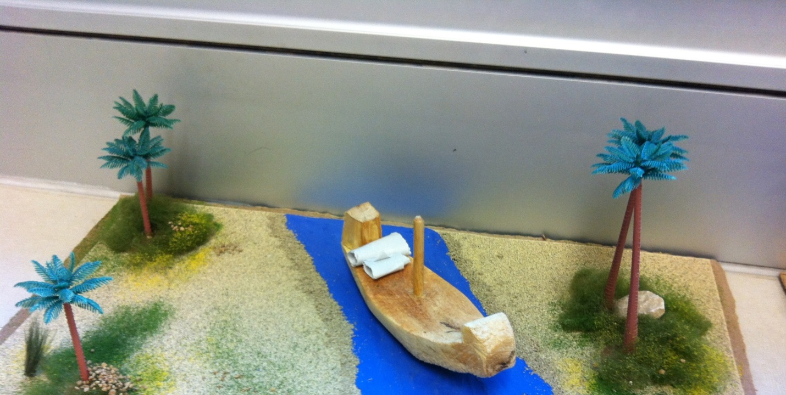
Cargo Boat for hauling goods up and down the Nile. Boat was hand carved.
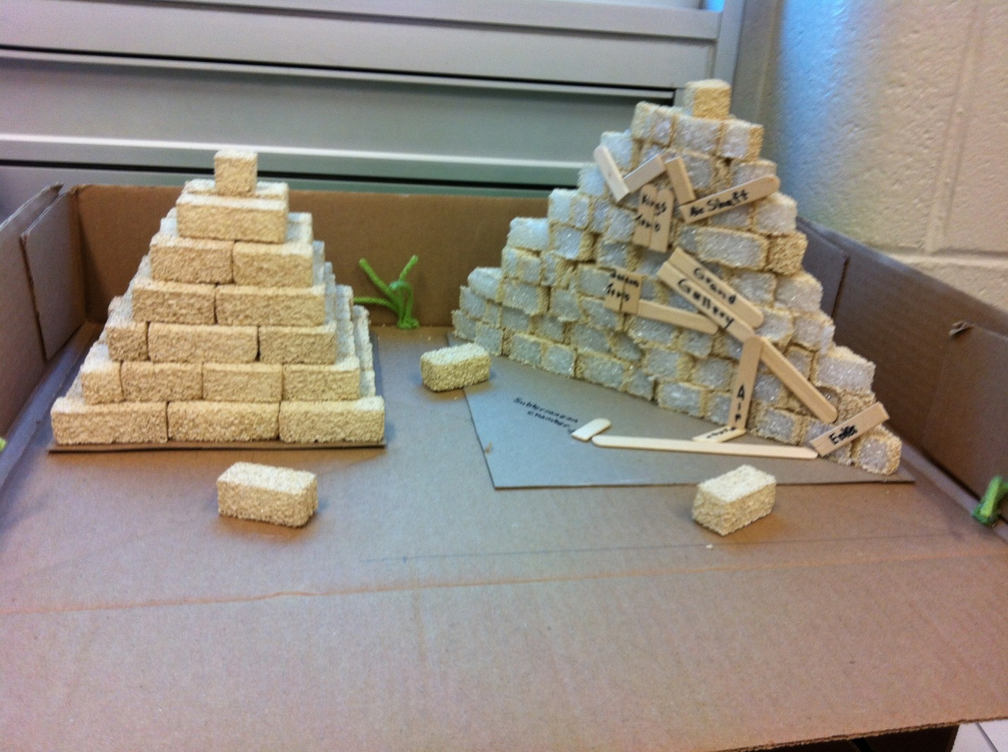
Pyramid cross section – Inside components labelled.
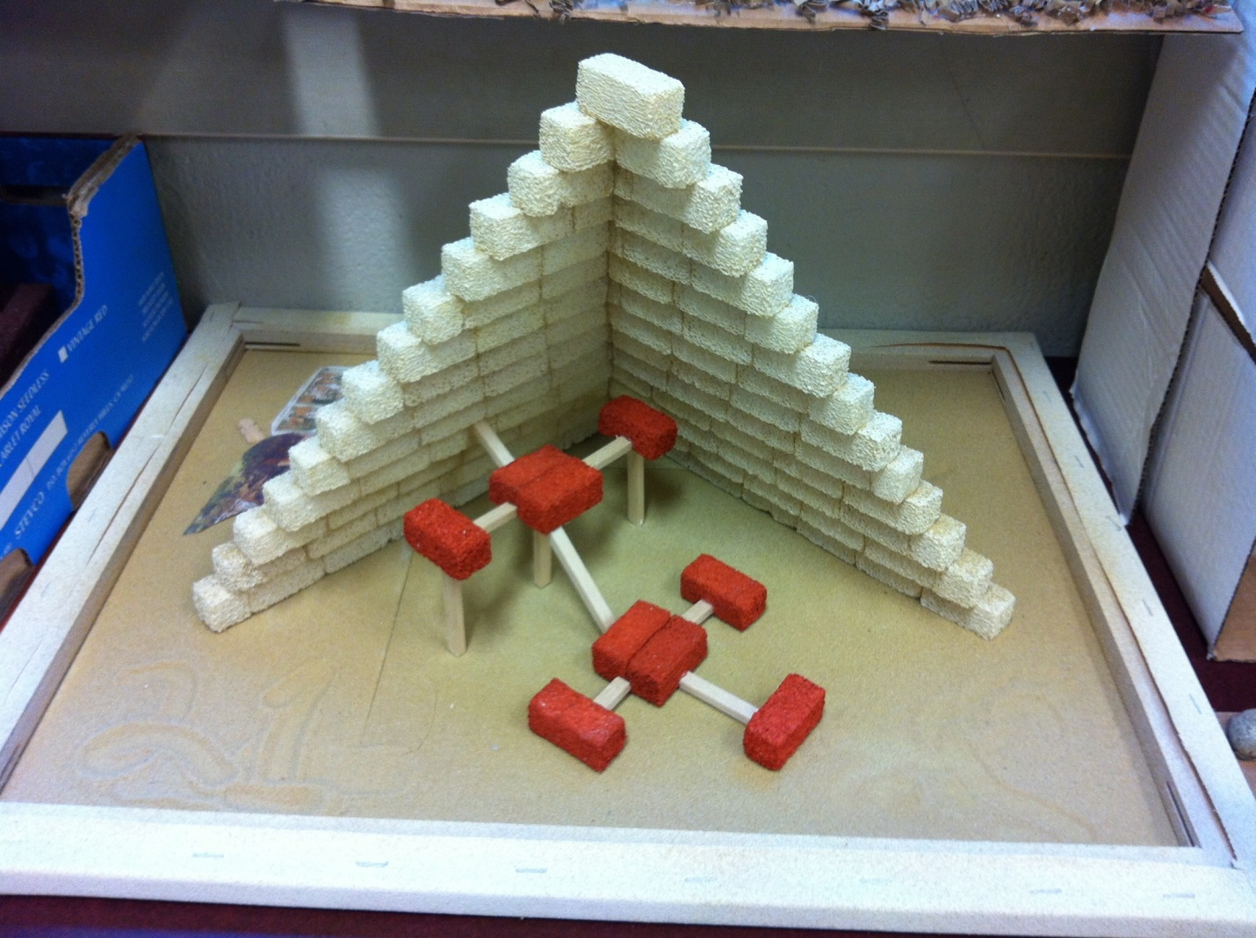
Pyramid cross section – various rooms, secret passages, and levels inside a pyramid.
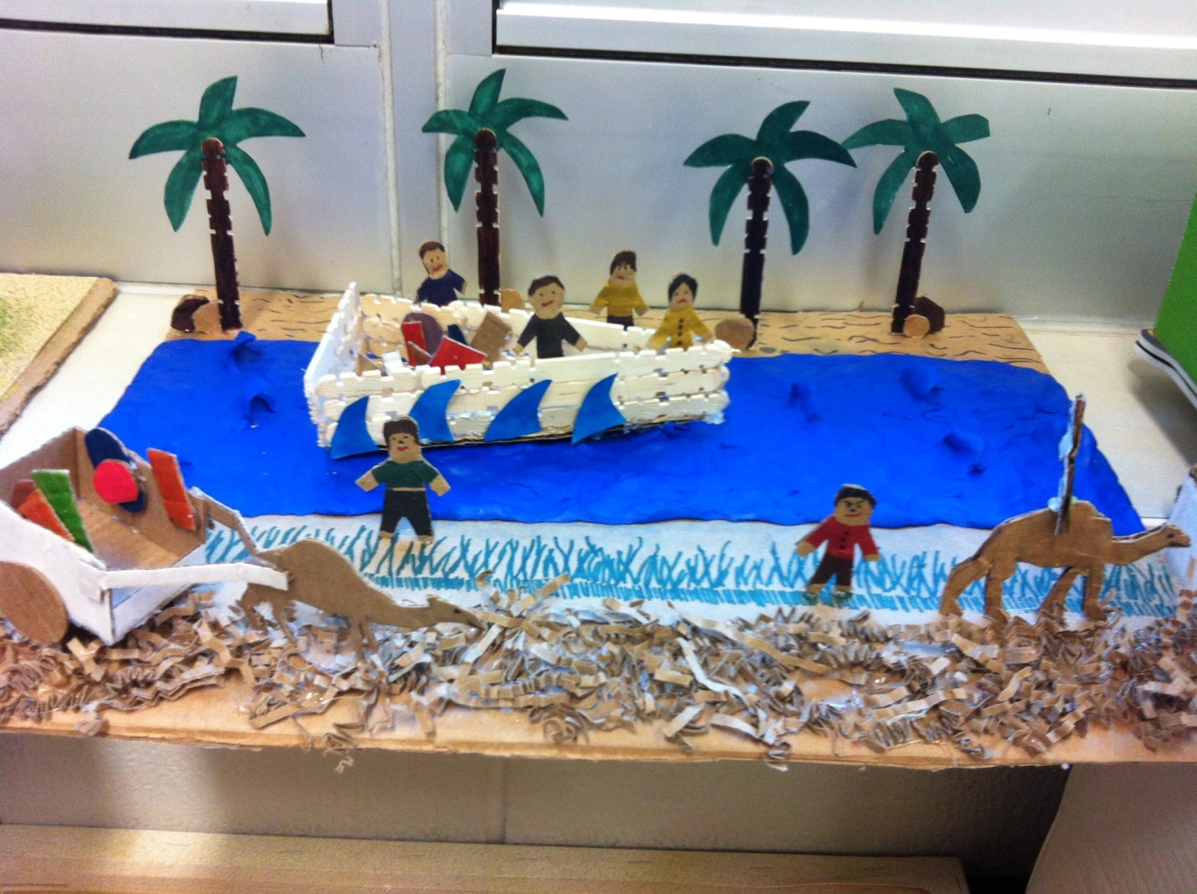
Transportation in Egypt in its various forms. Cart, royalty, walking, boat. Class-structure
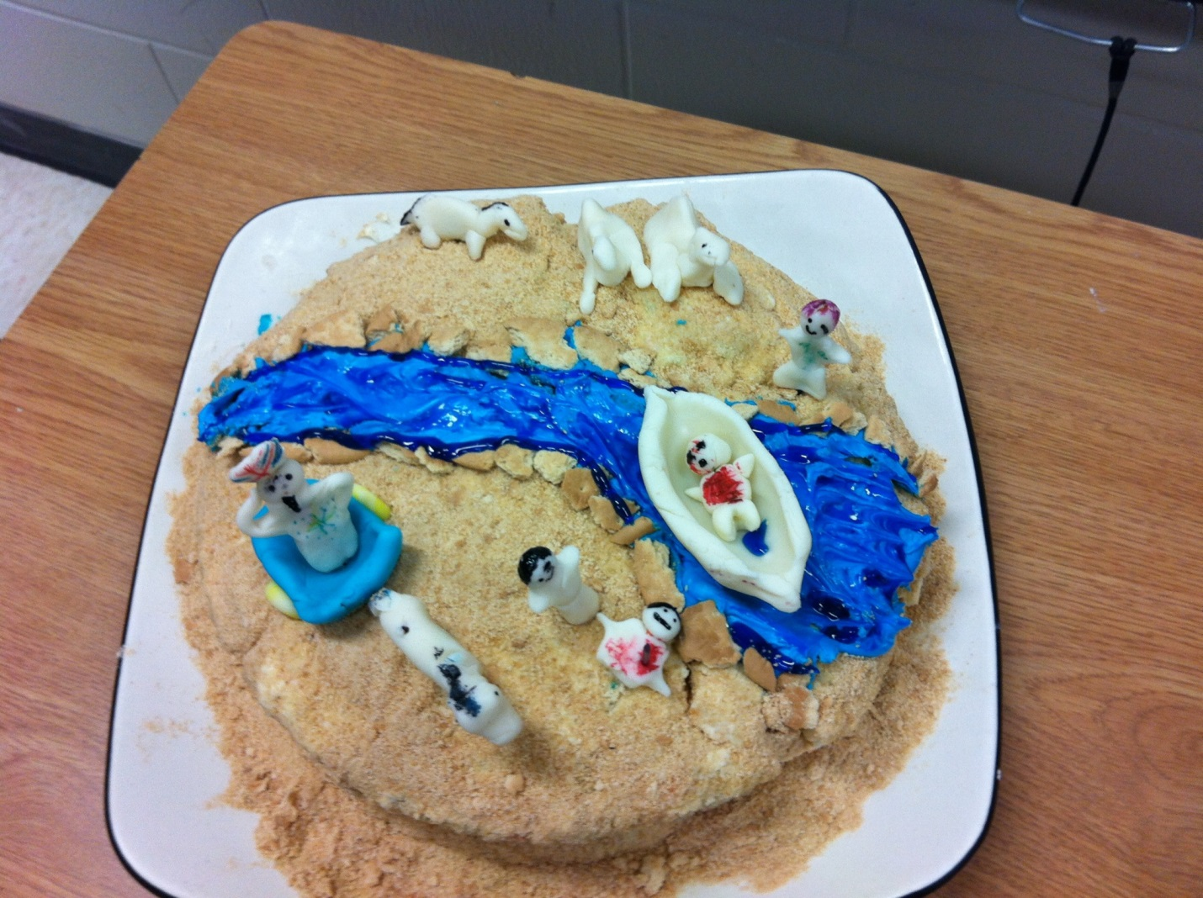
Transportation in Egypt – edible edition! Made as a cake which we ate afterwards!

