Hammurabi’s Code
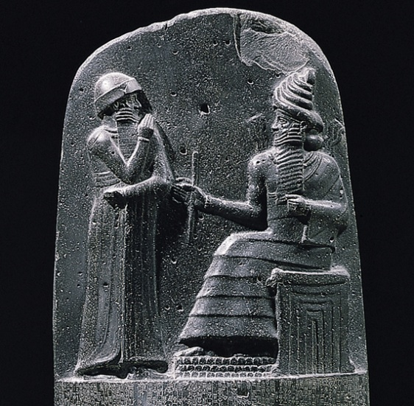
Hammurabi was the first king of the Babylonian empire, living from 1792-1750 BC. Hammurabi is best known for creating a set of laws known as “Hammurabi’s Code”. These laws were inscribed on stone tablets standing over eight feet tall. “An eye for an eye” is probably the most famous of these laws.
While many of these laws may seem barbaric and strange, they are significant in that it shows this society had established a set code of conduct and provided detailed consequences for not following their rules.

Assignment
Skim through the 282 laws on Hammurabi’s code. Choose one law and create, on an 8 ½ X 11 sheet of paper, an image which correlates to that law.
Your Assignment:
- Both your law and idea for image of that law, must be approved by Mr. Rowland prior to starting.
- Must contain both images and the writing of the law itself.
- Must be coloured.

Rubric:
Law present/Detail - ___/5
Image quality/Coloured - ____/5
Finished Product - ____/5

