S. ST. 9
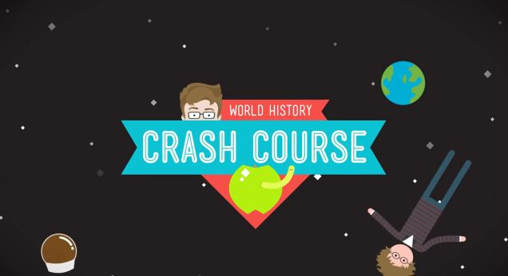
Crash Course Video

Throughout our course we have often watched John Green’s Crash Course World History videos as a way to quickly summarize cultures and time period that we have studied. Green uses many tools to help explain history, including:

- Humour
- Visual aids
- An Open Letter to…
- Me from the past
- Secret Compartment

Your group will be given a section of the Roman Republic, which you must become “mini-experts” on and create a ~ 1 min “Crash Course” video which explains your concept. Your video will be a teaching tool, so consider how you can use visuals, humour, etc. to ensure that your concept sticks in your audience’s mind.

Groups

- Romulus and Remus
- Rome’s geographic advantage
- Romans overthrew their kings and established a republic
- Class Structure and SPQR
- Roman Army
- Rome’s balanced government – consuls, senate, people, dictator
- Rome won control of Italy
- Rome fought Carthage & First Punic War
- 2nd Punic war, Hannibal, Battle of Zama, 3rd Punic War
Assessment

Planning/Storyboarding – Storyboards are complete, video is well-thought out and executed accordingly

5 4 3 2 1

Content – Group has researched beyond their handout, knowledge presented reflects their being ‘mini-experts’. Group has made smart choices in what info to include and what info to omit. Audience has a clear understanding of the topic.

5 4 3 2 1

Humour/Visuals/Originality – Group has thought of creative ways to display their information. Their video is enjoyed by the audience.

5 4 3 2 1

Use of Class time/ Individual Effort – You have been a contributing member of your group and have contributed to your video’s success.

5 4 3 2 1

TOTAL - ____/20

