Primitive and Civilized
Instructions
PRIMITIVE
- On your stick person, draw characteristics that make this person “primitive”
  - Think Clothing, tools, facial features, etc…
- On the right side – list the characteristics that make this person primitive, use your drawing to help you out
- Using your drawing and your list of characteristics create a great definition for the term “Primitive”
CIVILIZED
- On your stick person, draw characteristics that make this person “Civilized”
  - Think Clothing, tools, facial features, etc…
- On the right side – list the characteristics that make this person civilized, use your drawing to help you out
- Using your drawing and your list of characteristics create a great definition for the term “Civilized”
Primitive -
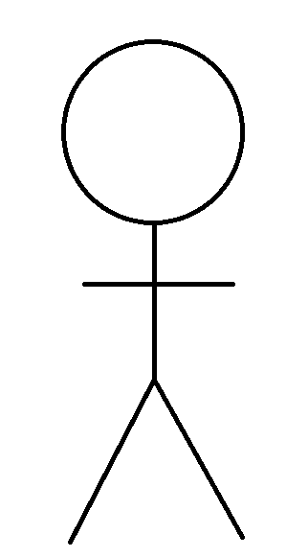

Civilized -

Questions to look at:
- Which group determines who and who is not civilized? Why?

- Are there any better terms to describe the division of societies other than “Civilized” and “Primitive”? If so let’s think of a few.

